Result on Question 2

1. Solution

In order to do simple regression analysis between the goal difference in game 1 and the goal difference in game 2 from the perspective of Team 1, the linear regression function lm() in R has been used for this solution.

After reversing the goal difference of second game to get it from the perspective of Team 1, the linear regression model was built.

The point distribution plane of linear regression model has been drawn as following.

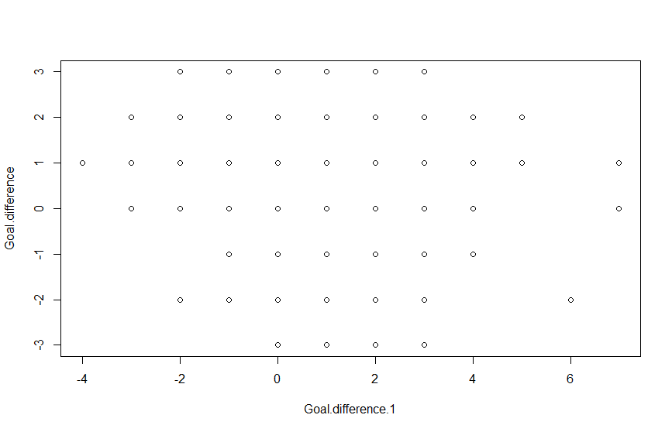

Fig 1. Point distribution plane of linear regression model

And, we can get the coefficients of linear regression from the model by abline().

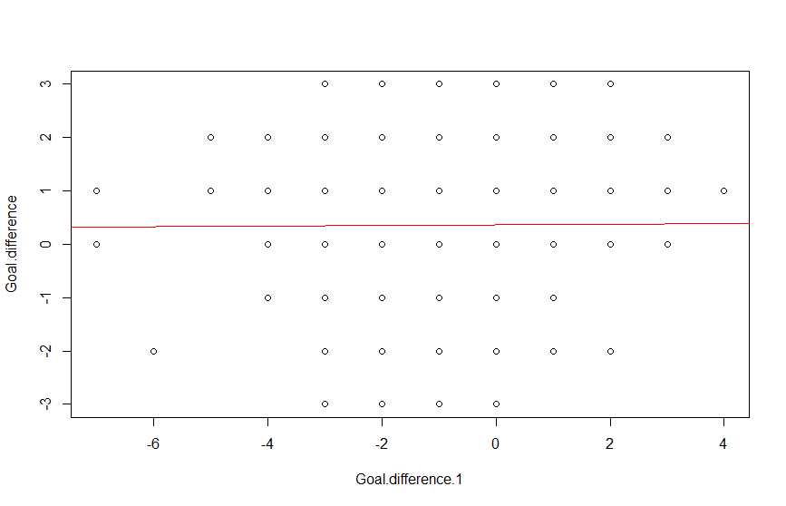

The coefficients of the linear regression model are [0.36426, 0.00516]

Also, the correlation between two variables has been calculated by cor() function in R.

The correlation is 0.006305

1. Conclusion

As you can see, there is a tiny dependency between the goal difference in game 1 and the goal difference in game 2 from the perspective of Team 1. I think there is any relation between two variables